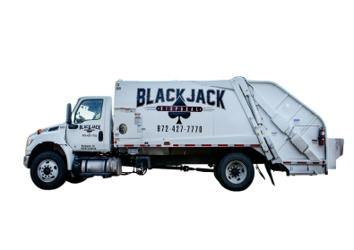


RESIDENTIAL SANITATION GUIDELINES

🗑️ YOUR POLYCART
- Use the approved BlackJack Disposal polycart provided for your residence.
- Personal or unauthorized trash cans will not be emptied.
- Place household trash inside the polycart. One (1) additional bag of household trash may be placed out for collection
- Do not overload the cart or place excessively heavy materials inside it.
- Keep the polycart lid closed.
- Place your polycart at the curb no later than 7:00 a.m. on your collection day and within ten (10) feet of curb.
- If you need an additional polycart, contact the City of Edgewood Water Department at 903-896-7144.
BlackJack Disposal's standard residential cart is a 95-gallon polycart.

🛋️ BULK ITEM & BRUSH PICKUP - *PLEASE CALL THE CITY TO SET THIS UP FOR YOU*
Each week, BlackJack Disposal will collect ONE (1) of the following:

ONE BULK ITEM OR ONE CUBIC YARD OF BRUSH (1 cubic yard = approximately 3' x 3' x 3')
If you have a question about whether a particular item qualifies as a bulk item, please contact the City before placing it at the curb.

🚫 ITEMS THAT WILL NOT BE COLLECTED WITH REGULAR TRASH
BlackJack Disposal's residential guidelines indicate that the following materials are not accepted as regular household trash:
Tires Automotive fluids Batteries Electronics
Pool chemicals Paint Household chemicals Bricks
Dirt Concrete Tile Shingles
Other excessively heavy materials
Do not place hazardous materials or prohibited items in your polycart or beside the cart. For information about disposal of items not accepted through regular residential collection, contact BlackJack Disposal.

📅 COLLECTION DAYS

NORTH OF HWY 80: WEDNESDAY SOUTH OF HWY 80: THURSDAY

HAVE QUESTIONS? NEED AN ADDITIONAL POLYCART? (are available for an additional monthly sanitation charge
Call the City of Edgewood Water Department, 107 N.E. Front Street, Edgewood, Texas 75117; 903-896-7144

HANDICAP STICKERS ARE AVAILABLE FOR QUALIFYING RESIDENTS. POLYCART MUST BE PLACED WITH STICKER VISIBLE FROM THE ROAD.

BlackJack Disposal: 972-427-7770
Please contact the City or BlackJack Disposal before placing an item at the curb if you are unsure whether it is eligible for collection.
Thank you for helping keep Edgewood clean!

